Ideation Phase

Brainstorm & Idea Prioritization Template

|  |  |
| --- | --- |
| Team ID | PNT2022TMID52303 |
| Project Name | Project – Smart waste management system for  metropolitan cities |

**Step-1: Team Gathering, Collaboration and Select the Problem Statement**

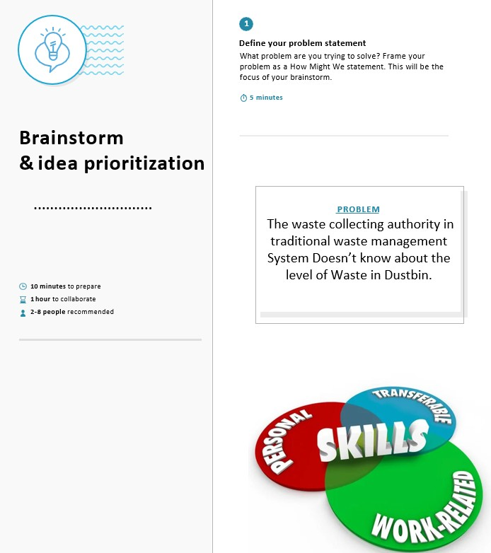

Step-2:Brainstorm,Idea Listing and Grouping

Team Leader Team Member 1

Barkavi.B Reshma.M

|  |
| --- |
| Opinion from Government |

|  |
| --- |
| Find a  New  bug |

|  |
| --- |
| Collects all smart waste |

|  |
| --- |
| Clean free metro-  politian cities |

|  |
| --- |
| Uses may damage the sensors |

|  |
| --- |
| Cost increasing rapidly |

|  |
| --- |
| Recognize all dustbins in roadside |

|  |
| --- |
| Simple Managing machines |

Team Member 2 Team Member 3

Jemisha.F Siva jothi.S

|  |
| --- |
| Resulting in less man work |

|  |
| --- |
| Easy to  **Smart implementation**  handle the waste |

|  |
| --- |
| Improve effiency |

|  |
| --- |
| Reduce expenses for  disposal |

|  |
| --- |
| Free  From  diseases |

|  |
| --- |
| Encourage recycling |

|  |
| --- |
| Reduce the pollution |

Step-3: Idea Prioritization

